Practical 12
Problem Definition
Develop event management functionality for admin users. Admin can add, view, update, delete, and upload event posters with file type and file size validation.
Code:-
Db.php:-
<?php
$host = "localhost";
$dbname = "studenthub";
$username = "root";
$password = "";

try {
$pdo = new PDO(
"mysql:host=$host;dbname=$dbname;charset=utf8mb4",
$username,
$password
);

$pdo->setAttribute(
PDO::ATTR_ERRMODE,
PDO::ERRMODE_EXCEPTION
);
} catch (PDOException $e) {
exit("Database connection failed.");
}
?>
Events.php:-

<?php
session_start();
require "db.php";

$message = "";
$uploadDir = __DIR__ . "/uploads/";

if (!is_dir($uploadDir)) {
mkdir($uploadDir, 0755, true);
}

// Delete event
if (isset($_GET["delete"])) {
$id = filter_input(INPUT_GET, "delete", FILTER_VALIDATE_INT);

if ($id) {
$stmt = $pdo->prepare("SELECT poster FROM events WHERE id = ?");
$stmt->execute([$id]);
$event = $stmt->fetch(PDO::FETCH_ASSOC);

if ($event) {
$stmt = $pdo->prepare("DELETE FROM events WHERE id = ?");
$stmt->execute([$id]);

if (!empty($event["poster"])) {
$oldFile = $uploadDir . basename($event["poster"]);
if (is_file($oldFile)) {
unlink($oldFile);
}
}

header("Location: events.php?msg=deleted");
exit;
}
}
}

// Load event for editing
$editEvent = null;

if (isset($_GET["edit"])) {
$id = filter_input(INPUT_GET, "edit", FILTER_VALIDATE_INT);

if ($id) {
$stmt = $pdo->prepare("SELECT * FROM events WHERE id = ?");
$stmt->execute([$id]);
$editEvent = $stmt->fetch(PDO::FETCH_ASSOC);
}
}

// Add or update event
if ($_SERVER["REQUEST_METHOD"] === "POST") {
$id = filter_input(INPUT_POST, "id", FILTER_VALIDATE_INT);
$title = trim($_POST["title"] ?? "");
$description = trim($_POST["description"] ?? "");
$eventDate = $_POST["event_date"] ?? "";
$venue = trim($_POST["venue"] ?? "");
$posterName = null;
$oldPoster = "";

if ($id) {
$stmt = $pdo->prepare("SELECT poster FROM events WHERE id = ?");
$stmt->execute([$id]);
$existing = $stmt->fetch(PDO::FETCH_ASSOC);

if (!$existing) {
$message = "Event not found.";
} else {
$oldPoster = $existing["poster"] ?? "";
}
}

if (!$message && ($title === "" || $eventDate === "" || $venue === "")) {
$message = "Please fill in all required fields.";
}

if (!$message && $eventDate !== "") {
$date = DateTime::createFromFormat("!Y-m-d", $eventDate);

if (!$date || $date->format("Y-m-d") !== $eventDate) {
$message = "Please enter a valid event date.";
}
}

// Validate uploaded poster
if (!$message && isset($_FILES["poster"])
&& $_FILES["poster"]["error"] !== UPLOAD_ERR_NO_FILE) {

$file = $_FILES["poster"];

if ($file["error"] !== UPLOAD_ERR_OK) {
$message = "Poster upload failed.";
} elseif ($file["size"] > 2 * 1024 * 1024) {
$message = "Poster must be 2 MB or smaller.";
} else {
$finfo = new finfo(FILEINFO_MIME_TYPE);
$mime = $finfo->file($file["tmp_name"]);

$allowed = [
"image/jpeg" => "jpg",
"image/png" => "png",
"image/webp" => "webp"
];

if (!isset($allowed[$mime])) {
$message = "Only JPG, PNG, and WEBP posters are allowed.";
} else {
$posterName = bin2hex(random_bytes(16))
. "." . $allowed[$mime];

if (!move_uploaded_file(
$file["tmp_name"],
$uploadDir . $posterName
)) {
$message = "Could not save the poster.";
$posterName = null;
}
}
}
}

if (!$message) {
try {
if ($id) {
if ($posterName !== null) {
$sql = "UPDATE events
SET title=?, description=?, event_date=?,
venue=?, poster=?
WHERE id=?";
$values = [
$title, $description, $eventDate,
$venue, $posterName, $id
];
} else {
$sql = "UPDATE events
SET title=?, description=?, event_date=?,
venue=?
WHERE id=?";
$values = [
$title, $description, $eventDate,
$venue, $id
];
}

$stmt = $pdo->prepare($sql);
$stmt->execute($values);

if ($posterName !== null && $oldPoster !== "") {
$oldFile = $uploadDir . basename($oldPoster);
if (is_file($oldFile)) {
unlink($oldFile);
}
}

header("Location: events.php?msg=updated");
exit;
} else {
$stmt = $pdo->prepare(
"INSERT INTO events
(title, description, event_date, venue, poster)
VALUES (?, ?, ?, ?, ?)"
);

$stmt->execute([
$title, $description, $eventDate,
$venue, $posterName
]);

header("Location: events.php?msg=added");
exit;
}
} catch (PDOException $e) {
if ($posterName !== null && is_file($uploadDir . $posterName)) {
unlink($uploadDir . $posterName);
}
$message = "Could not save the event. Check your database table.";
}
}
}

if (isset($_GET["msg"])) {
$messages = [
"added" => "Event added successfully!",
"updated" => "Event updated successfully!",
"deleted" => "Event deleted successfully!"
];
$message = $messages[$_GET["msg"]] ?? "";
}

// Fetch all events
$stmt = $pdo->query("SELECT * FROM events ORDER BY id DESC");
$events = $stmt->fetchAll(PDO::FETCH_ASSOC);

function h($value) {
return htmlspecialchars((string)$value, ENT_QUOTES, "UTF-8");
}
?>

<!DOCTYPE html>
<html lang="en">
<head>
<meta charset="UTF-8">
<meta name="viewport" content="width=device-width, initial-scale=1.0">
<title>StudentHub - Event Management</title>

<style>
* { box-sizing: border-box; }

body {
font-family: Arial, sans-serif;
background: #f0f4f8;
margin: 0;
padding: 20px;
color: #222;
}

.container {
max-width: 1000px;
margin: auto;
}

h1, h2 { text-align: center; color: #17365d; }

.form-box, .table-box {
background: white;
padding: 20px;
margin: 20px 0;
border-radius: 10px;
box-shadow: 0 2px 8px #ccc;
}

label {
display: block;
margin-top: 12px;
font-weight: bold;
}

input, textarea {
width: 100%;
padding: 10px;
margin-top: 5px;
border: 1px solid #bbb;
border-radius: 5px;
}

button, .btn {
display: inline-block;
border: none;
border-radius: 5px;
padding: 10px 14px;
margin-top: 12px;
background: #1769aa;
color: white;
text-decoration: none;
cursor: pointer;
}

.delete { background: #c62828; }
.cancel { background: #666; }

.message {
background: #e0f5e5;
color: #176b32;
padding: 12px;
border-radius: 5px;
}

.table-scroll { overflow-x: auto; }

table {
width: 100%;
border-collapse: collapse;
min-width: 700px;
}

th, td {
border: 1px solid #ddd;
padding: 10px;
text-align: left;
}

th { background: #17365d; color: white; }

.poster {
width: 90px;
height: 65px;
object-fit: cover;
}

@media (max-width: 600px) {
body { padding: 8px; }
.form-box, .table-box { padding: 12px; }
}
</style>
</head>

<body>
<div class="container">

<h1>StudentHub Event Management</h1>
<p style="text-align:center">
<a class="btn" href="index.php">Home</a>
</p>

<?php if ($message !== ""): ?>
<p class="message"><?= h($message) ?></p>
<?php endif; ?>

<div class="form-box">
<h2><?= $editEvent ? "Update Event" : "Add New Event" ?></h2>

<form method="POST" enctype="multipart/form-data">
<input type="hidden" name="id"
value="<?= h($editEvent["id"] ?? "") ?>">

<label>Event Title *</label>
<input type="text" name="title" required maxlength="150"
value="<?= h($editEvent["title"] ?? "") ?>">

<label>Description</label>
<textarea name="description" rows="4"><?= h(
$editEvent["description"] ?? ""
) ?></textarea>

<label>Event Date *</label>
<input type="date" name="event_date" required
value="<?= h($editEvent["event_date"] ?? "") ?>">

<label>Venue *</label>
<input type="text" name="venue" required maxlength="150"
value="<?= h($editEvent["venue"] ?? "") ?>">

<label>Event Poster (JPG, PNG, WEBP; max 2 MB)</label>
<input type="hidden" name="MAX_FILE_SIZE" value="2097152">
<input type="file" name="poster" accept=".jpg,.jpeg,.png,.webp">

<?php if (!empty($editEvent["poster"])): ?>
<p>Current poster:</p>
<img class="poster"
src="uploads/<?= h(basename($editEvent["poster"])) ?>"
alt="Current event poster">
<p>Choose a new poster only if you want to replace it.</p>
<?php endif; ?>

<button type="submit">
<?= $editEvent ? "Update Event" : "Add Event" ?>
</button>

<?php if ($editEvent): ?>
<a class="btn cancel" href="events.php">Cancel</a>
<?php endif; ?>
</form>
</div>

<div class="table-box">
<h2>All Events</h2>

<div class="table-scroll">
<table>
<thead>
<tr>
<th>ID</th>
<th>Poster</th>
<th>Title</th>
<th>Description</th>
<th>Date</th>
<th>Venue</th>
<th>Actions</th>
</tr>
</thead>

<tbody>
<?php if (!$events): ?>
<tr>
<td colspan="7">No events found.</td>
</tr>
<?php else: ?>
<?php foreach ($events as $event): ?>
<tr>
<td><?= h($event["id"]) ?></td>
<td>
<?php if (!empty($event["poster"])): ?>
<img class="poster"
src="uploads/<?= h(basename($event["poster"])) ?>"
alt="Event poster">
<?php else: ?>
No poster
<?php endif; ?>
</td>
<td><?= h($event["title"]) ?></td>
<td><?= h($event["description"]) ?></td>
<td><?= h($event["event_date"]) ?></td>
<td><?= h($event["venue"]) ?></td>
<td>
<a class="btn"
href="events.php?edit=<?= (int)$event["id"] ?>">
Edit
</a>

<a class="btn delete"
href="events.php?delete=<?= (int)$event["id"] ?>"
onclick="return confirm('Are you sure you want to delete this event?')">
Delete
</a>
</td>
</tr>
<?php endforeach; ?>
<?php endif; ?>
</tbody>
</table>
</div>
</div>

<p style="text-align:center">© 2026 StudentHub</p>
</div>
</body>
</html>
Screenshot:-
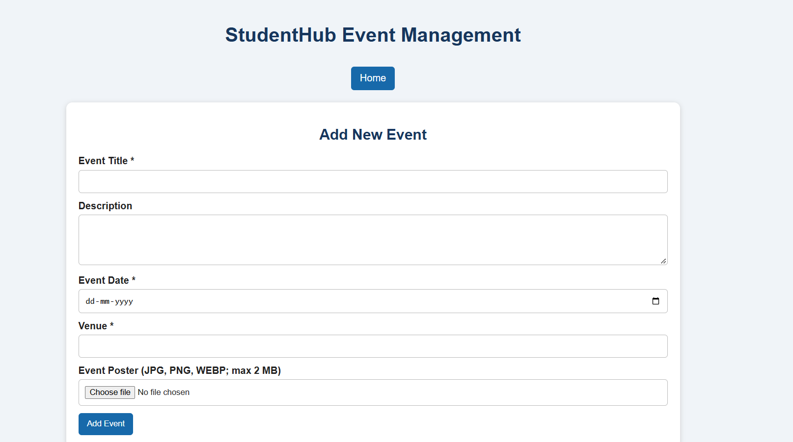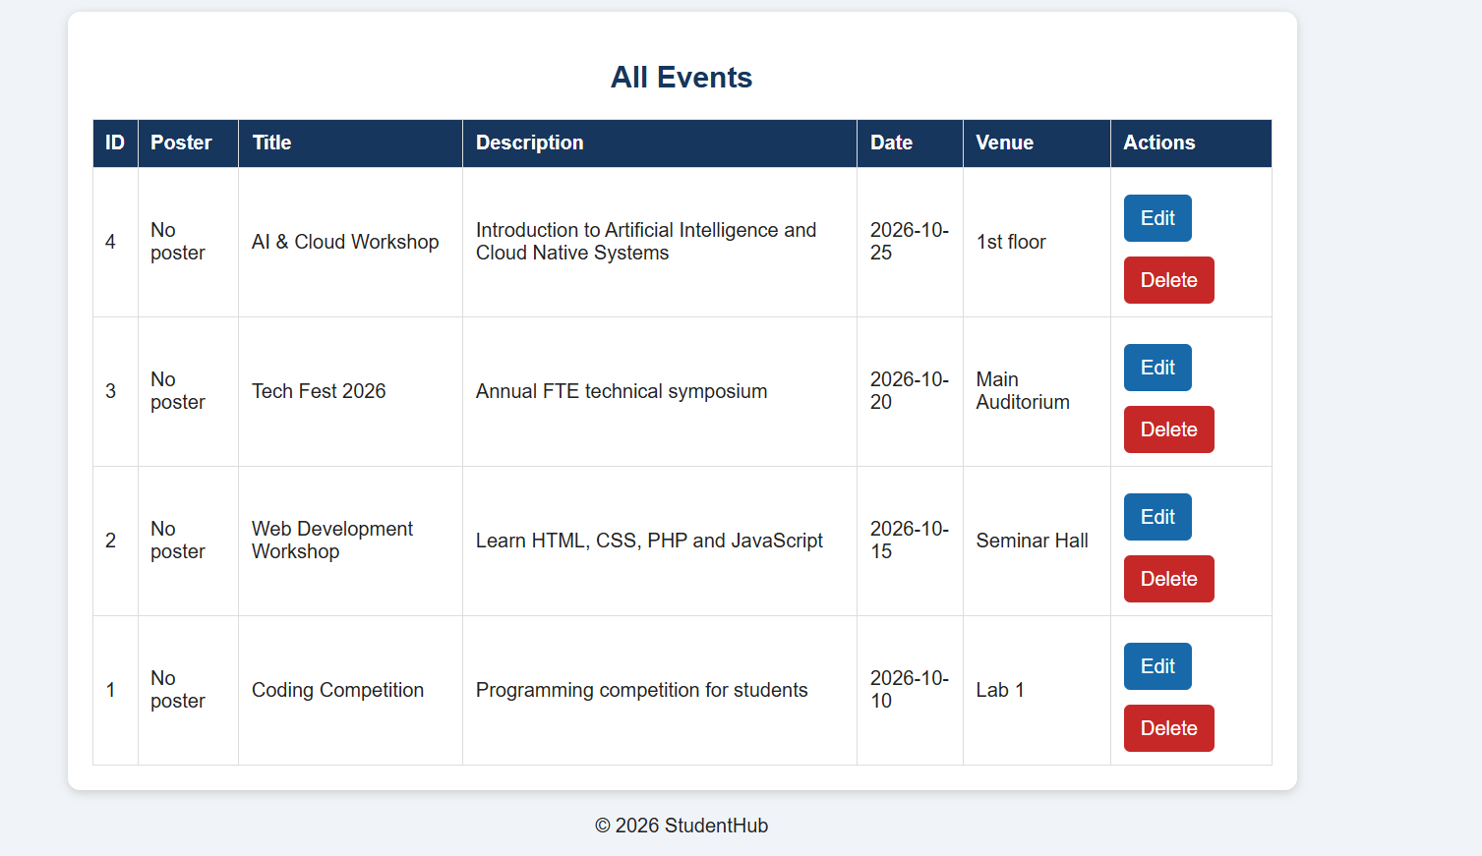
Add An Event Entry:-
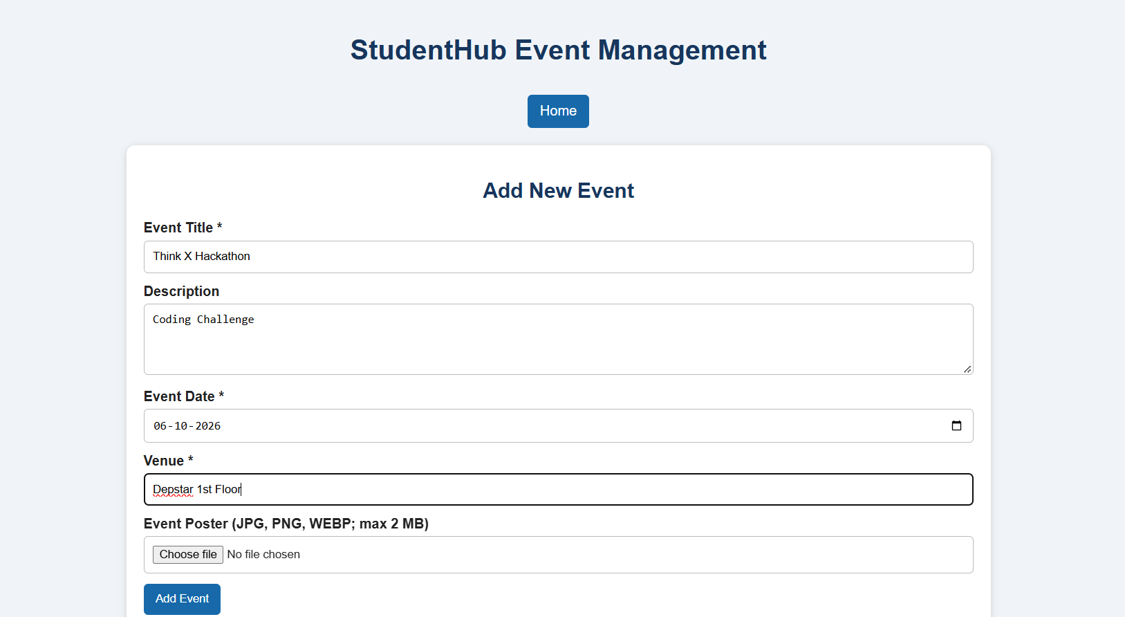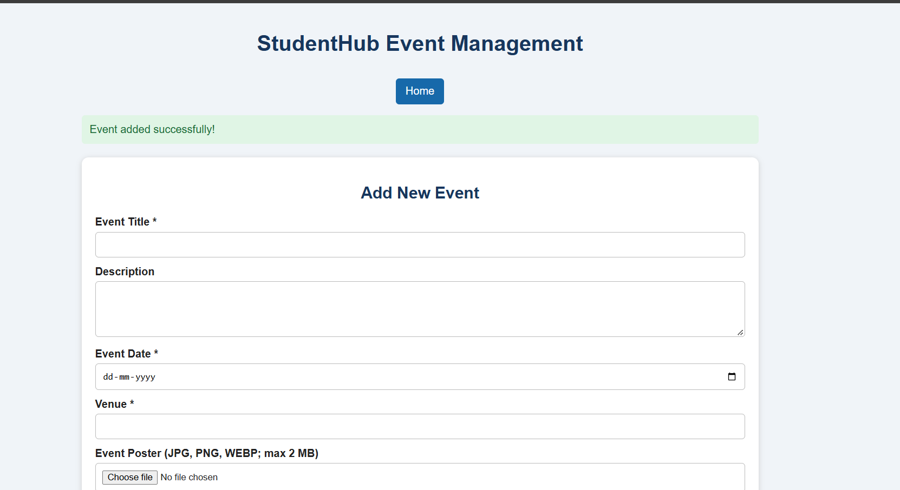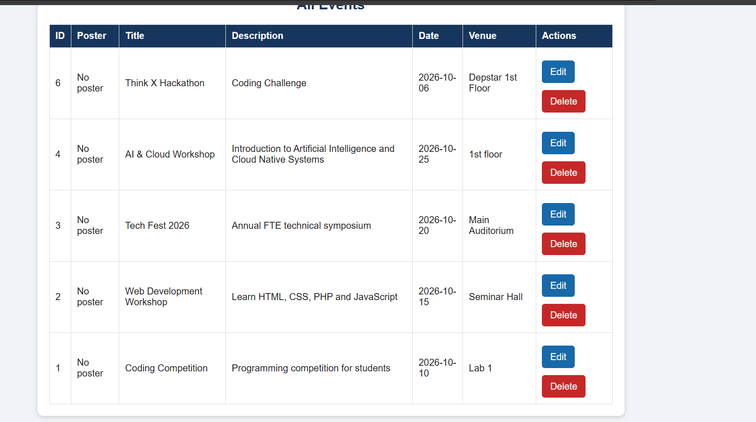
Delete an event:-
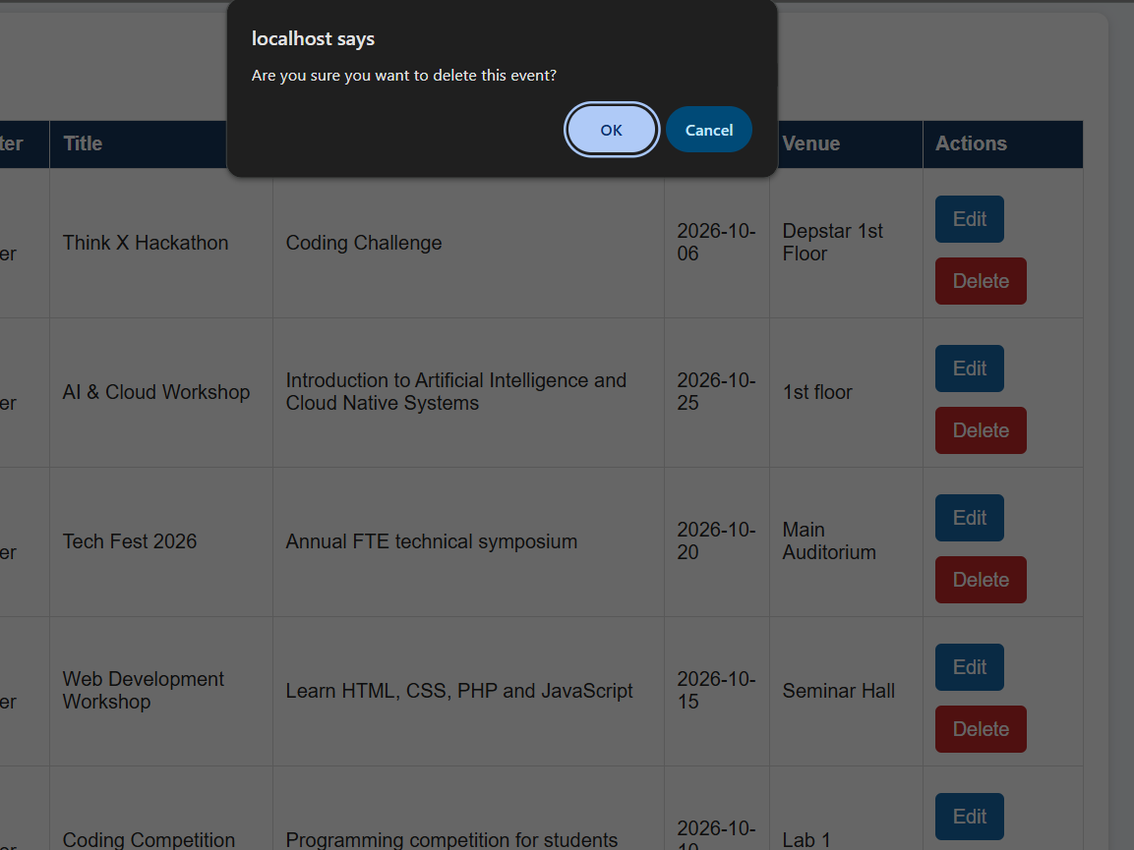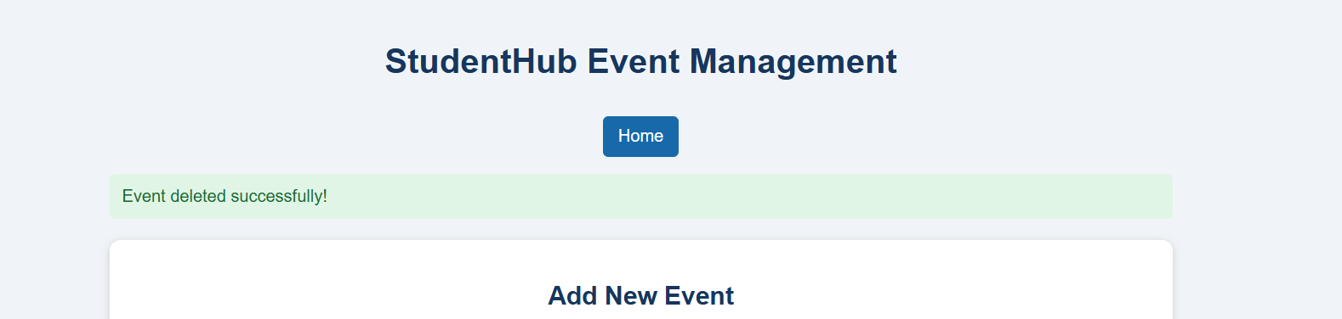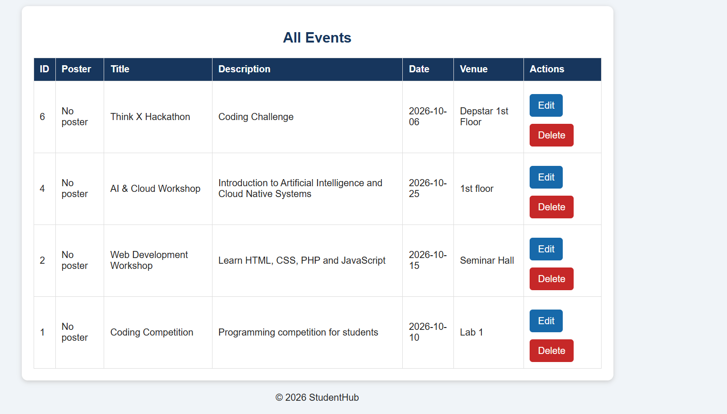
Edit an event details:-
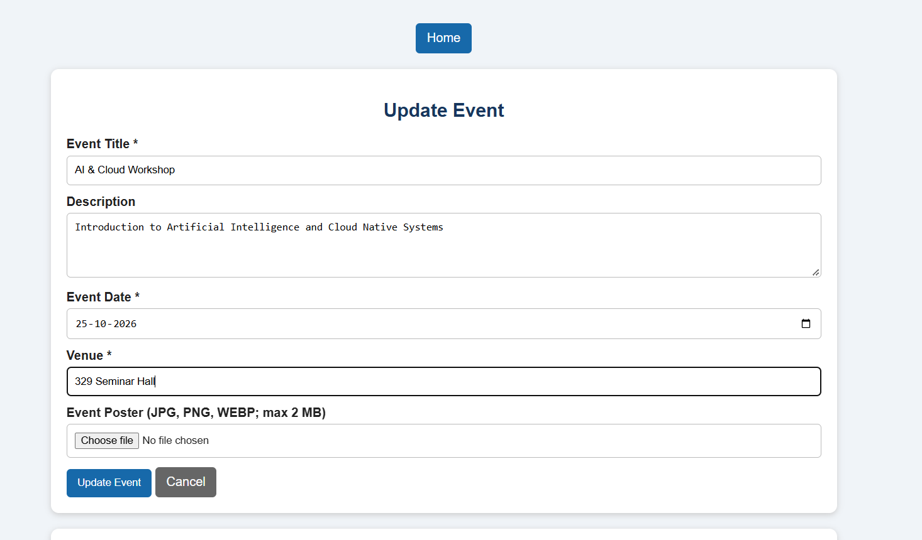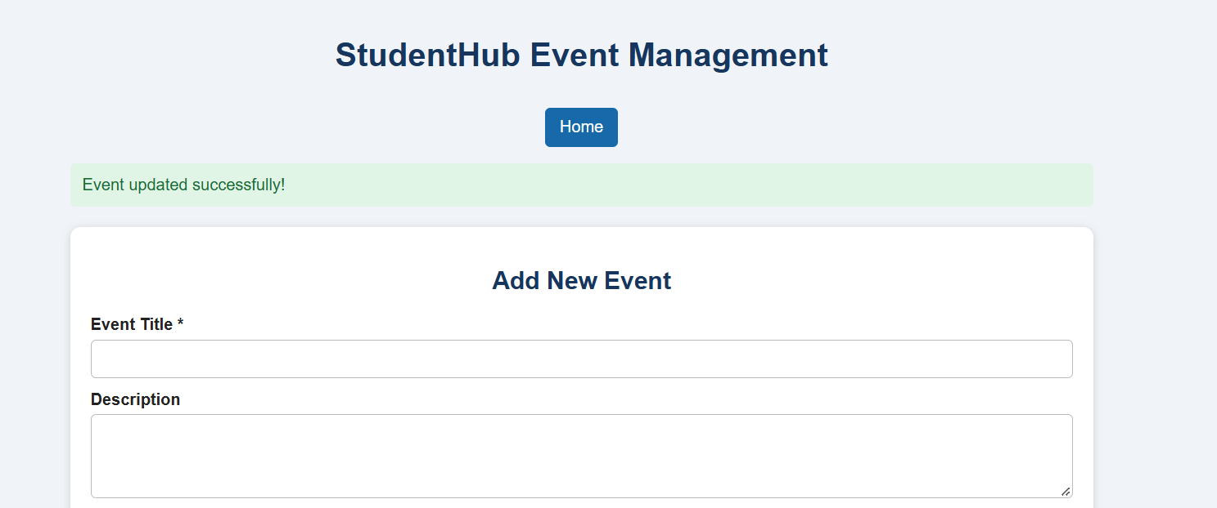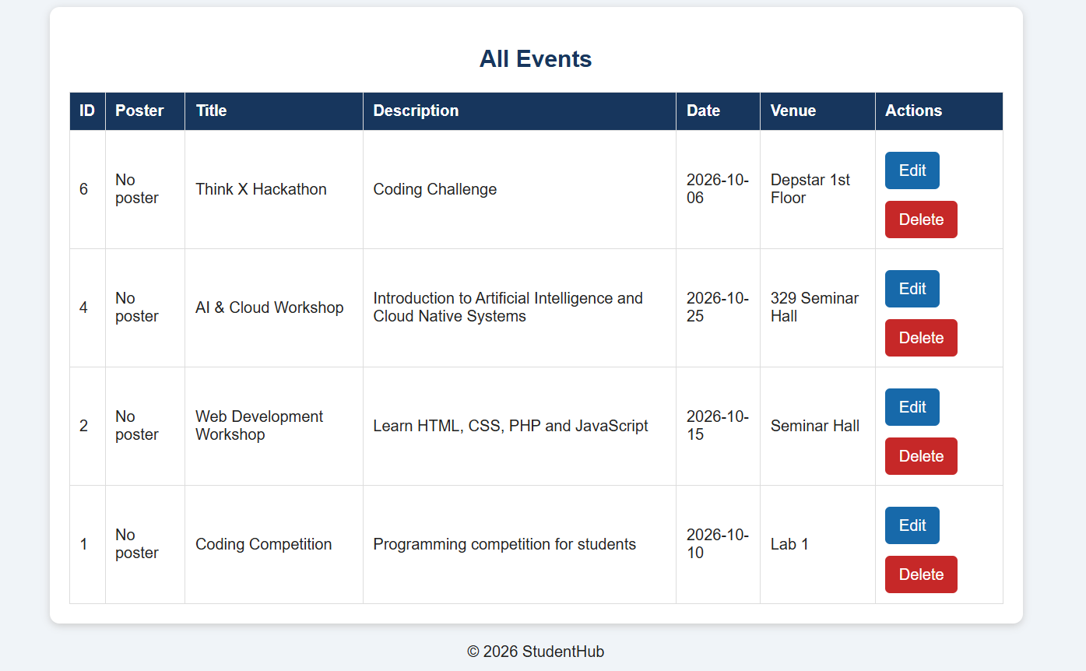
Key Questions / Analysis / Interpretation – Practical 12
1. Are add, update, and delete functionalities implemented correctly?
Yes, the system allows the admin to add new events, update existing event details, and delete events after confirmation.
2. Is the UI linked with the database correctly?
Yes, the PHP interface is connected to the MySQL database using PDO. Prepared statements are used to insert, retrieve, update, and delete event records.
3. Are poster uploads validated for type and size?
Yes, the system accepts JPG, PNG, and WEBP image files with a maximum size of 2 MB. Invalid file types and oversized files are rejected.
4. Are success and failure messages displayed?
Yes, success messages are displayed after adding, updating, or deleting events. Error messages are displayed for invalid inputs, failed uploads, and database errors.

